- Upon registering for the course, you will see a link in the Registration Portal with the option to “Order Textbooks”, you will click the link to view course materials.

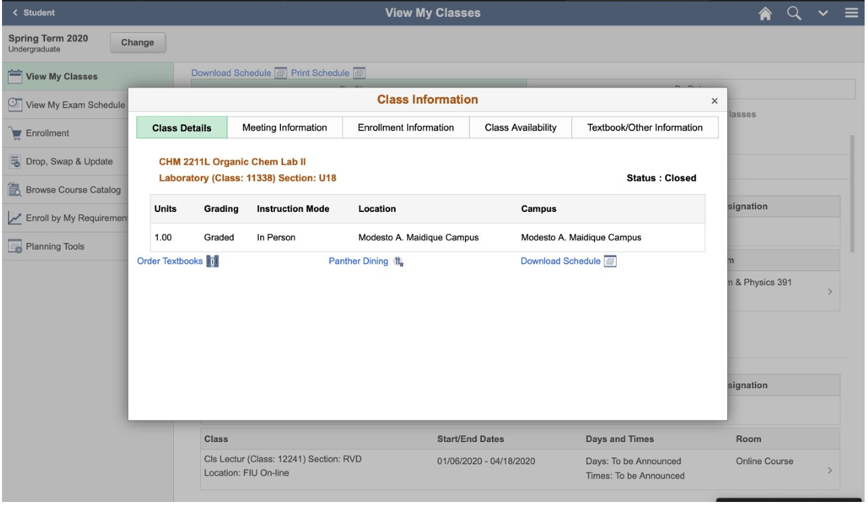

- Upon clicking the link, you will be redirected to the Barnes & Noble course materials page and see the required materials for the course(s) you are registered for.

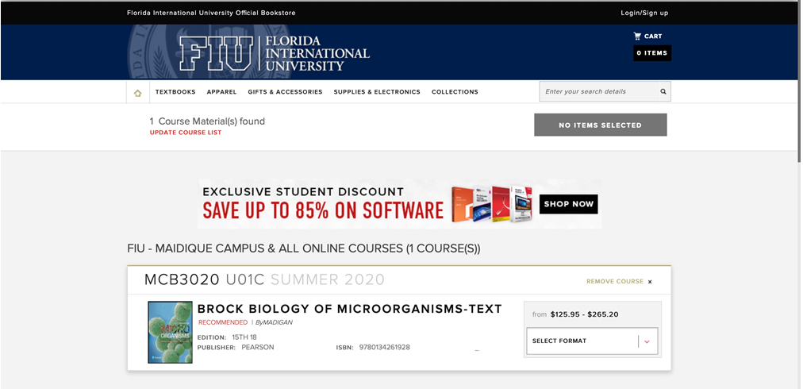

- You may proceed with selecting the course materials for purchase at this time. Please see requirements and recommendations that you must adhere to when making a purchase:
  - For all digital books (e-books) you must select the rental option, if it is available, instead of the new option. This option will grant you access to the course(s) materials for the duration of the course, after which access will be automatically revoked.

  - Purchasing course materials for which a digital book (e-book) is not available, you must select to purchase the used option, if it is available, instead of the new option. You cannot select the rent option for physical textbooks.

- If, after purchasing the course materials, you cannot take the course for any reason, it is your responsibility to coordinate a return of the course materials.
  - You must contact Barnes & Noble via email at fiubook@fiu.edu and ask that the order be cancelled, if it has not yet shipped.

  - If the order has shipped, then upon receipt of the course materials, you must contact your school counselor to coordinate the return of your course materials with FIU.

- Once you are ready to make a purchase, you should review the items in the cart on the Barnes & Noble website one last time and then select Checkout. You may only purchase textbooks, e-books and digital course materials as part of this order. You may check out as a guest or create a profile with a username and password and checkout. Upon checkout, you must select “voucher” as the payment method and enter your student ID and full name. Shipping is free for orders over $49.00 (note: need to make sure the school provides a purchase order to the bookstore before completing the order. It needs to be emailed to fiubook@fiu.edu.)

- You shall receive an email confirmation to the email listed at checkout once the order is placed. The access for any digital books (e-books) purchased that do not require a physical access code will be sent via email as well. Some e-books will have the immediate electronic access once that email is received, others will have a physical access code that will be shipped to the student.

- Following the end of the term, you should return all physical textbooks directly to your dual enrollment coordinator or school counselor.

