- Upon registering for the course, you will see a link in the Registration Portal with the option to “Order Textbooks”, you will click the link to view course materials.

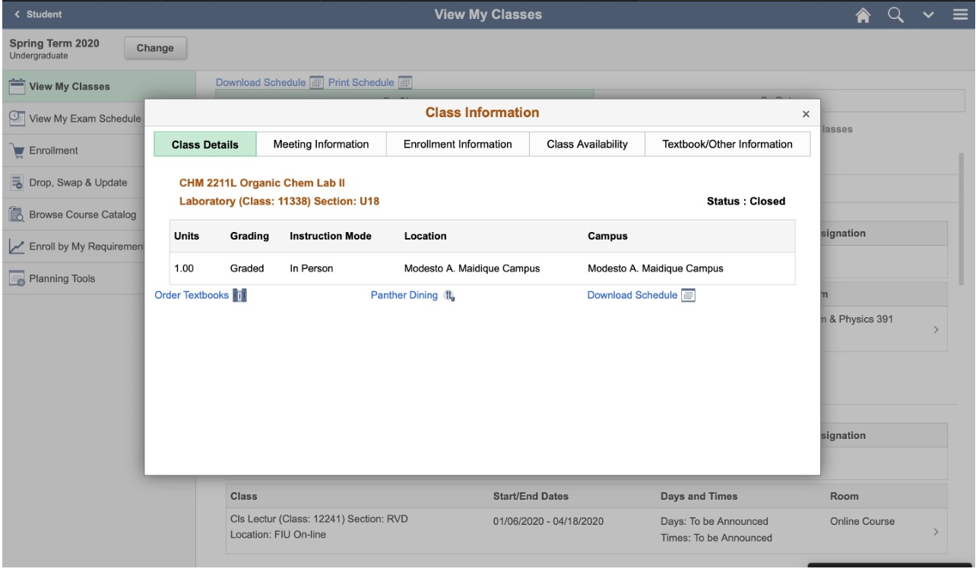

- Upon clicking the link, you will be redirected to the Barnes & Noble course materials page and see the required materials for the course(s) you are registered for.

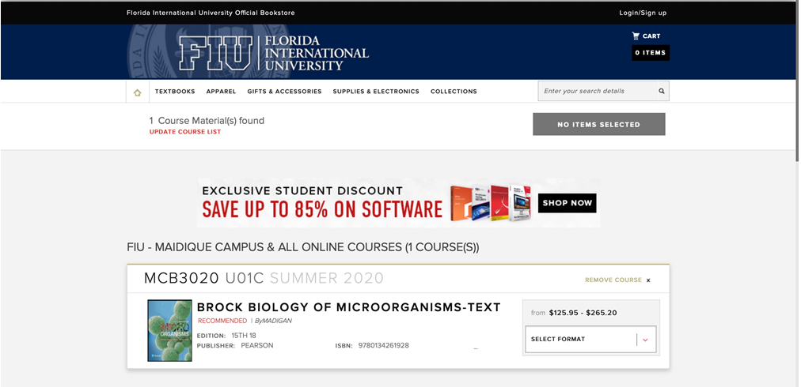

- You may proceed with selecting the course materials for purchase at this time.

- If, after purchasing the course materials, you cannot take the course for any reason, it is your responsibility to coordinate a return of the course materials.
  - You must contact Barnes & Noble via email at fiubook@fiu.edu and ask that the order be cancelled, if it has not yet shipped.

- Once you are ready to make a purchase, you should review the items in the cart on the Barnes & Noble website one last time and then select Checkout. You may check out as a guest or create a profile with a username and password and checkout. Upon checkout, you can enter the credit card information as the payment method. Shipping is free for orders over $49.00.

- You shall receive an email confirmation to the email listed at checkout once the order is placed. The access for any digital books (e-books) purchased that do not require a physical access code will be sent via email as well. Some e-books will have the immediate electronic access once that email is received, others will have a physical access code that will be shipped to the student.

